NATIONAL INSTITUTE OF TECHNOLOGY KARNATAKA SURATHKAL

DEPARTMENT OF INFORMATION TECHNOLOGY

**IT 301 Parallel Computing LAB 8**

14th October 2020

**Faculty: Dr. Geetha V and Mrs. Thanmayee**

**Name:** Chinmayi C. Ramakrishna

**Roll No.:** 181IT113

1. **MPI “Hello World” program:**

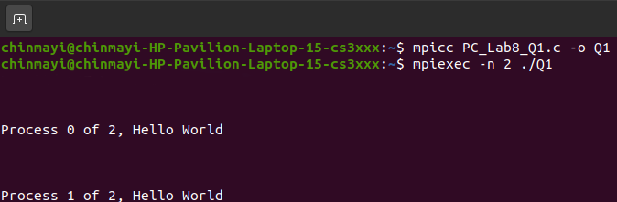

1. **Demonstration of MPI_Send() and MPI_Recv(). Sending an Integer.**

**Code:**

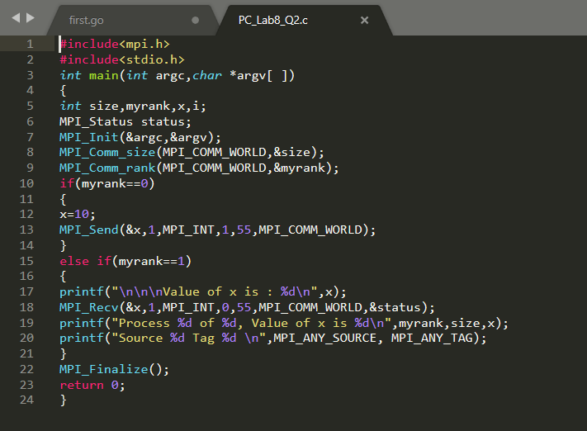

**Output:**

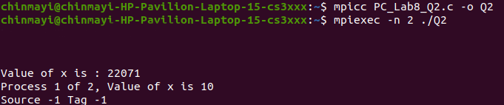

1. **Demonstration of MPI_Send() and MPI_Recv(). Sending a string.**

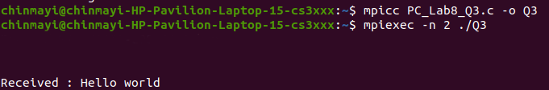

1. **Demonstration of MPI_Send() and MPI_Recv(). Sending elements of an array.**

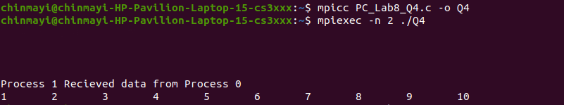

1. **Demonstration of Blocking Send and Receive with mismatched tags.**

**Output:**

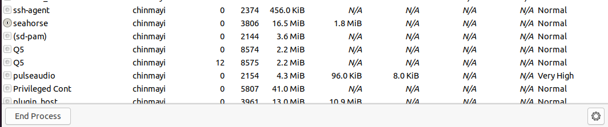

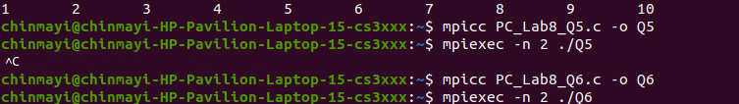

The process ends when the code is exited.

1. **MPI_Send() and MPI_Recv() standard mode:**

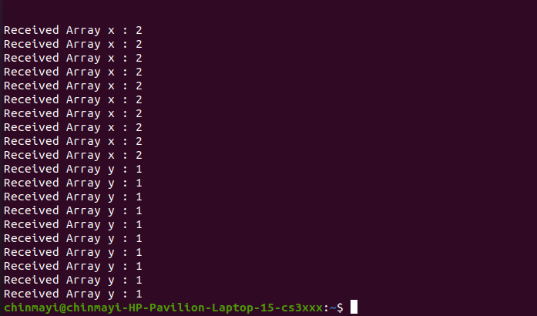

**a) Note down your observation on the content of x and y at Process 1.**

**b) Explain the importance of tag.**

When process 1 wants to send many different types of messages, it can use ids called tags so that the receiver can differentiate the messages.

**c) Write your analysis about Blocking Send and Receive. Whether it is advantageous?**

**d) What is the need for Non-blocking Send and Receive.**